Harnessing Satellite Imagery for Effective Flood
Detection Using Convolution Neural Network

Bhakti Ambarkar
G H Raisoni College Of Engineering, Department Of DIC Nagpur, India bhakti.ambarkar.ds@ghrce.raison.net

Dr. Chetankumar Dhule
Department of Data Science
G H Raisoni College of Engineering Nagpur, India
chetan.dhule@raisoni.net

Aman Singh
G H Raisoni College Of Engineering, Department Of DIC Nagpur, India aman.singh.ds@ghrce.raisoni.net
Dr. Rahul Agrawal
Department of Data Science
G H Raisoni College of Engineering Nagpur, India
rahul.agrawal@raisoni.net

Piyush Gupta
G H Raisoni College Of Engineering, Department Of DIC Nagpur, India piyush.gupta.ds@ghrce.raisoni.net
Prof. Nekita Chavhan Morris
Head of Department of DIC
G H Raisoni college of Engineering
Nagpur, India
nekita.chavan@raisoni.net

Abstract—Earth Observation has provided several fresh viewpoints from the geosciences to the monitoring of human activity during the past few decades. Artificial Intelligence (AI) algorithms produced very good results for analyzing remote sensing data as more data became available. Furthermore, a variety of acquisition methods, including Synthetic Aperture Radar (SAR), can be applied to issues that cannot be resolved with just optical pictures. This is especially true for weather-related catastrophes like hurricanes and floods, which are typically accompanied by dense clouds. However, the scarcity of labeled data makes machine learning on SAR data relatively difficult. We present a new dataset of co-registered optical and SAR image time series for flood event detection to aid the community moving forward.
Keywords— SAR Images (Synthetic Aperture Radar), Artificial Intelligence, catastrophes, Machine Learning

Introduction
One of the most destructive natural disasters on Earth, floods have a significant negative social and economic impact in along with suffering loss of life, damage to infrastructure, and destruction of crops. Recent changes in Earth's climate have led to an increase in the frequency of natural disasters due to the degradation of ecosystems. Overflowing rivers and breached embankments led to severe flooding across multiple states of India. Recently nearly 300 people died, and more than 1 million were displaced from their homes of the state of Uttar Pradesh. This flood made a vital impact on the infrastructure like hospitals, schools, and sanitation systems were crippled by the heavy floodwaters. Outbreaks of waterborne diseases became a major concern in the aftermath, endangering flood victims. The loss of crops and livestock pushed many farming families into acute distress and food insecurity.

Generally speaking, flooding is a major risk to cars and impedes traffic, which increases the possibility of swept-away cars, passenger injuries, and fatalities. In order to reduce the risk during meteorological events, cities must build flood maps using remote monitoring of flooding. Urban landscapes, on the other hand, are highly complex, featuring ponding, narrow, transient floods, streams with submeter resolutions, and discontinuous flooding degrees.
Conventional methods are employed for mapping flood risk and urban flooding. At small scales, high-resolution hydrologic modeling is effective, but obtaining the necessary computational power is challenging with current technology. For community-level urban flooding to be accurately estimated, incredibly accurate inputs are required. These restricting constraints highlight the need for less computationally demanding mapping or forecasting strategies for flooding. Remote sensing provides the benefit of large-scale flooding without the need for incredibly accurate inputs or computationally intensive procedures, hence increasing control over flood hazards. Studies on the prediction of floods have been carried out in domains such as satellite or aerial imaging. Regardless of the amount of cloud cover, the radar is an active sensor that continuously scans the surface of the Earth. Because of their shadow and delay in a complicated urban context, SAR data are shown to be inappropriate for tracking floods in urban areas. Unsupervised detection techniques are typically used to provide rapid flood mapping because there is a dearth of ground truth data accessible for practical uses. Nonetheless, some progress has been made in using SAR for urban flood applications thanks to more information and better protocols, as well as the incorporation of better data and novel image processing techniques.

In this dataset[12] convolutional neural network (CNN) with dilated convolutions, batch normalization, and non-linear activations such as LeakyReLU and ReLU.is applied. This model is applied on the tasks like image restoration, image colorization, or image enhancement, and it can be particularly helpful for processing SAR (Synthetic Aperture Radar) images. In this model we can easily classify the SAR images and predict the desired output using convolution neural network. This model uses convolutions, where the dilation rate increases and decreases throughout the layers. Dilated convolutions are effective at capturing both fine-grained local details important for textures and boundaries and more global, larger context important for capturing broader patterns in SAR images. The model’s batch normalization and non-linear activations help mitigate speckle noise, enhancing important features and improving image interpretability. By avoiding pooling layers, the model preserves spatial details, making it ideal for fine-grained spatial analysis.
Overall, the approach enhances SAR image usability for geological studies and environmental monitoring by providing meaningful colorized imagery.

RELATED WORK
Floods are commonly seen in various regions worldwide and are anticipated to worsen due to potential impacts of climate change in the future. Prior investigations have shown that advancements in remote sensing technologies have significantly boosted our ability to recognize and categorize objects on Earth. Advanced machine learning and sophisticated learning models are crucial for managing the unpredictable occurrences of natural calamities such as floods. Deep learning algorithms excel at automatically identifying important characteristics from unorganized data. Therefore, the training can be finished without needing manually labeled photos, which saves time and streamlines the system structure.
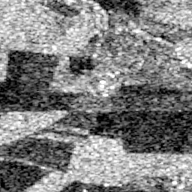
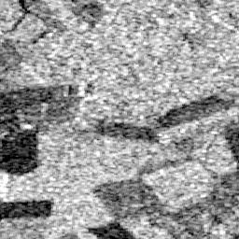
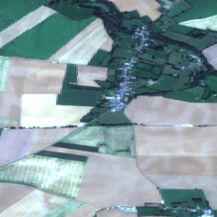
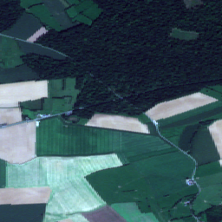
In the field of Convolutional neural networks (CNNs), for the classification of remote sensing images, have become the leading method. Their popularity stems from their superior accuracy in recognizing patterns and their robust network performance. They have been applied mostly on the natural disaster because of the high performance provided by the model. The ability to identify and categorize items on Earth has advanced significantly thanks to advances in technologies for remote sensing [7,9,11] CNN-based method for fully automated flood mapping using Sentinel-1 SAR imagery, reducing map development time by 80% and requiring minimal pre-processing. By the help of this model, we mostly reach to the accuracy of 91% to 94%. A majority vote was used to decide whether or not an area was flooded.
Fig 2(a) Sentinel 1 Image
Fig 2(b) Sentinel 1 Image
Fig 1(a) Sentinel 2 Image
Fig 1(b) Sentinel 2 Image

In paper [1] supervised models like Random Forest (RF), Support Vector Machine (SVM), and Maximum Likelihood Classifier (MLC) were employed. The image processing in the given paper is done by ESA SNAP which ensure the data consistency. Unsupervised methods are also favored for robust early flood detection without needing training data, complementing supervised approaches like Sentinel 1 image-based backscatter intensity classification. Similarly in paper [2,5] unsupervised learning is applied the preprocessing of the image is done using NDWI, and performing GEOBIA classification. Preprocessing includes atmospheric correction and geometric correction. NDWI distinguishes water bodies using NIR and green bands. GEOBIA segments images and applies threshold-based classification to identify flooded areas, incorporating NDWI and GLCM homogeneity to reduce false positives.

But a real time flood detection system can also be made using UAV(s) to detect flood detection using aerial images. By these methods you can reach up to 90%- 91% [6] of accuracy of detection roads and green land farms. Meanwhile, in China, [6] yet another intriguing idea was mooted. Researchers combined the visible imagery from the Gaofen GF satellites with Zhuhai-1 hyperspectral images and proposed a new coarse-to-fine flood mapping framework. With a preprocessing step for rough segmentation of water bodies, the approach did not stop there. Fine-tuned flood detection came next, using a U-Net model, noisy-label learning, and T-revision. Furthermore, VNG Flood V1.0 allowed for extensive disaster monitoring by generating near real-time flood maps using Suomi-NPP/VIIRS data with resolutions of 375 meters. Even for this product, positive feedback from experts in the field was obtained with the integration of multiple bands, this found to be a useful tool in detecting floods over large regions while floods continue to be one of the most destructive forces of nature, the integration of technology.

Data and Methodology

Dataset
A set of multispectral Sentinel 2 images[Fig 1(a) & 1(b)] can be accessed using the city-centered satellite sequences made available by Bischke et al. (2019) as part of the Mediaeval 2019 Multimedia Satellite difficulties. The regions under observation are cities in Africa, Iran, and Australia as well as the territories around them, whether or not there was flooding during the time period. These photos have 12 bands, a 10 m ground sampling distance, with Level 2A atmospheric adjustment applied. Here, we provide a fresh dataset that matches the Sentinel 1[Fig 2(a) & 2(b)] sequences for the same regions and time frames. On the other hand, a larger sample rate results from the retrieval of more SAR photos for the same time period because SAR is not affected by cloud cover. Approximately twice as many photos make up this SAR collection as there are in the optical one. Approximately double as many images make up this SAR gathering as there are in the optical one. We merge our dataset with the Mediaeval dataset to create the latest SEN12-Flood dataset, which takes advantage of both SAR and optical modalities.
Every image is labeled with a binary classification signifying if flooding seems to have happened in the area shown. The Copernicus Emergency Management Service initially gathered the labels from the Mediaeval 2019 dataset. The ESA's Scientific website could give access to the images from Sentinel 1. The data was collected using the Interferometric Wide Swath (IW) mode, with polarizations VV and VH. SAR images come with Ground Range Detected High Resolution (GRDH) products that have a resolution of 10 by 10 meters. The SNAP ESA program (Brockmann) used the digital elevation model from the Space Shuttle Radar Topographic Mission for radiometric calibration and Range Doppler Terrain Correction of SAR images, as per Miranda (2015). On average, each set consists of fourteen SAR images and nine optical images. The opportunity to make purchases is available from December 2018 to May 2019. Forty percent of the optical Sentinel 2 photos and forty percent of the SAR Sentinel 1 images display evidence of a flood. Just like the Mediaeval dataset, all subsequent images in the series are classified as Flooded during a flood event. This label indicates that the surface shows clear changes for a significant amount of time following the event.

Methodology
To demonstrate the importance of this dataset, we employed the cutting-edge ResNet-50 (He et al., 2015) network to identify instances of flooding in every image. The first convolutional layer of this network was altered to accommodate for the proper number of bands in SAR (2 bands) and multispectral (12 bands) data. This network was intended for the categorization of RGB images. This suggests that for these two configurations, the network had to be completely retrained, however for The network that was previously trained could be used to help clarify the baseline's accuracy differences using the RGB images. The models were trained with a learning rate of 7 x 10⁻⁶ over 400 epochs using Stochastic Gradient Descent for the SAR and multispectral settings. Also, in my model we have calculated the total loss, Eucliden loss, Total variation loss. Total loss is a measurement utilized in machine learning and deep learning to evaluate the performance of a model. Total loss is a single number that represents the sum of all individual losses across a dataset. It quantifies the discrepancy between the goal values and the model's projections. The goal in training a machine learning model is to minimize this total loss, which in turn improves the model's performance. General formula for total loss is given by:

L = (1/N) * Σ(i=1 to N) l(y_i, ŷ_i)

Equation 1: General formula for Total Loss

L (Total loss) is the model's overall performance across all dataset samples is indicated by this metric. The total count of data points or examples in your dataset that you're utilizing to compute the loss is represented by N (Number of samples). The specific function used to determine the inaccuracy or difference between the anticipated and true value for a single data point is called the "individual loss function," or "l." The real, accurate value or label for the i-th

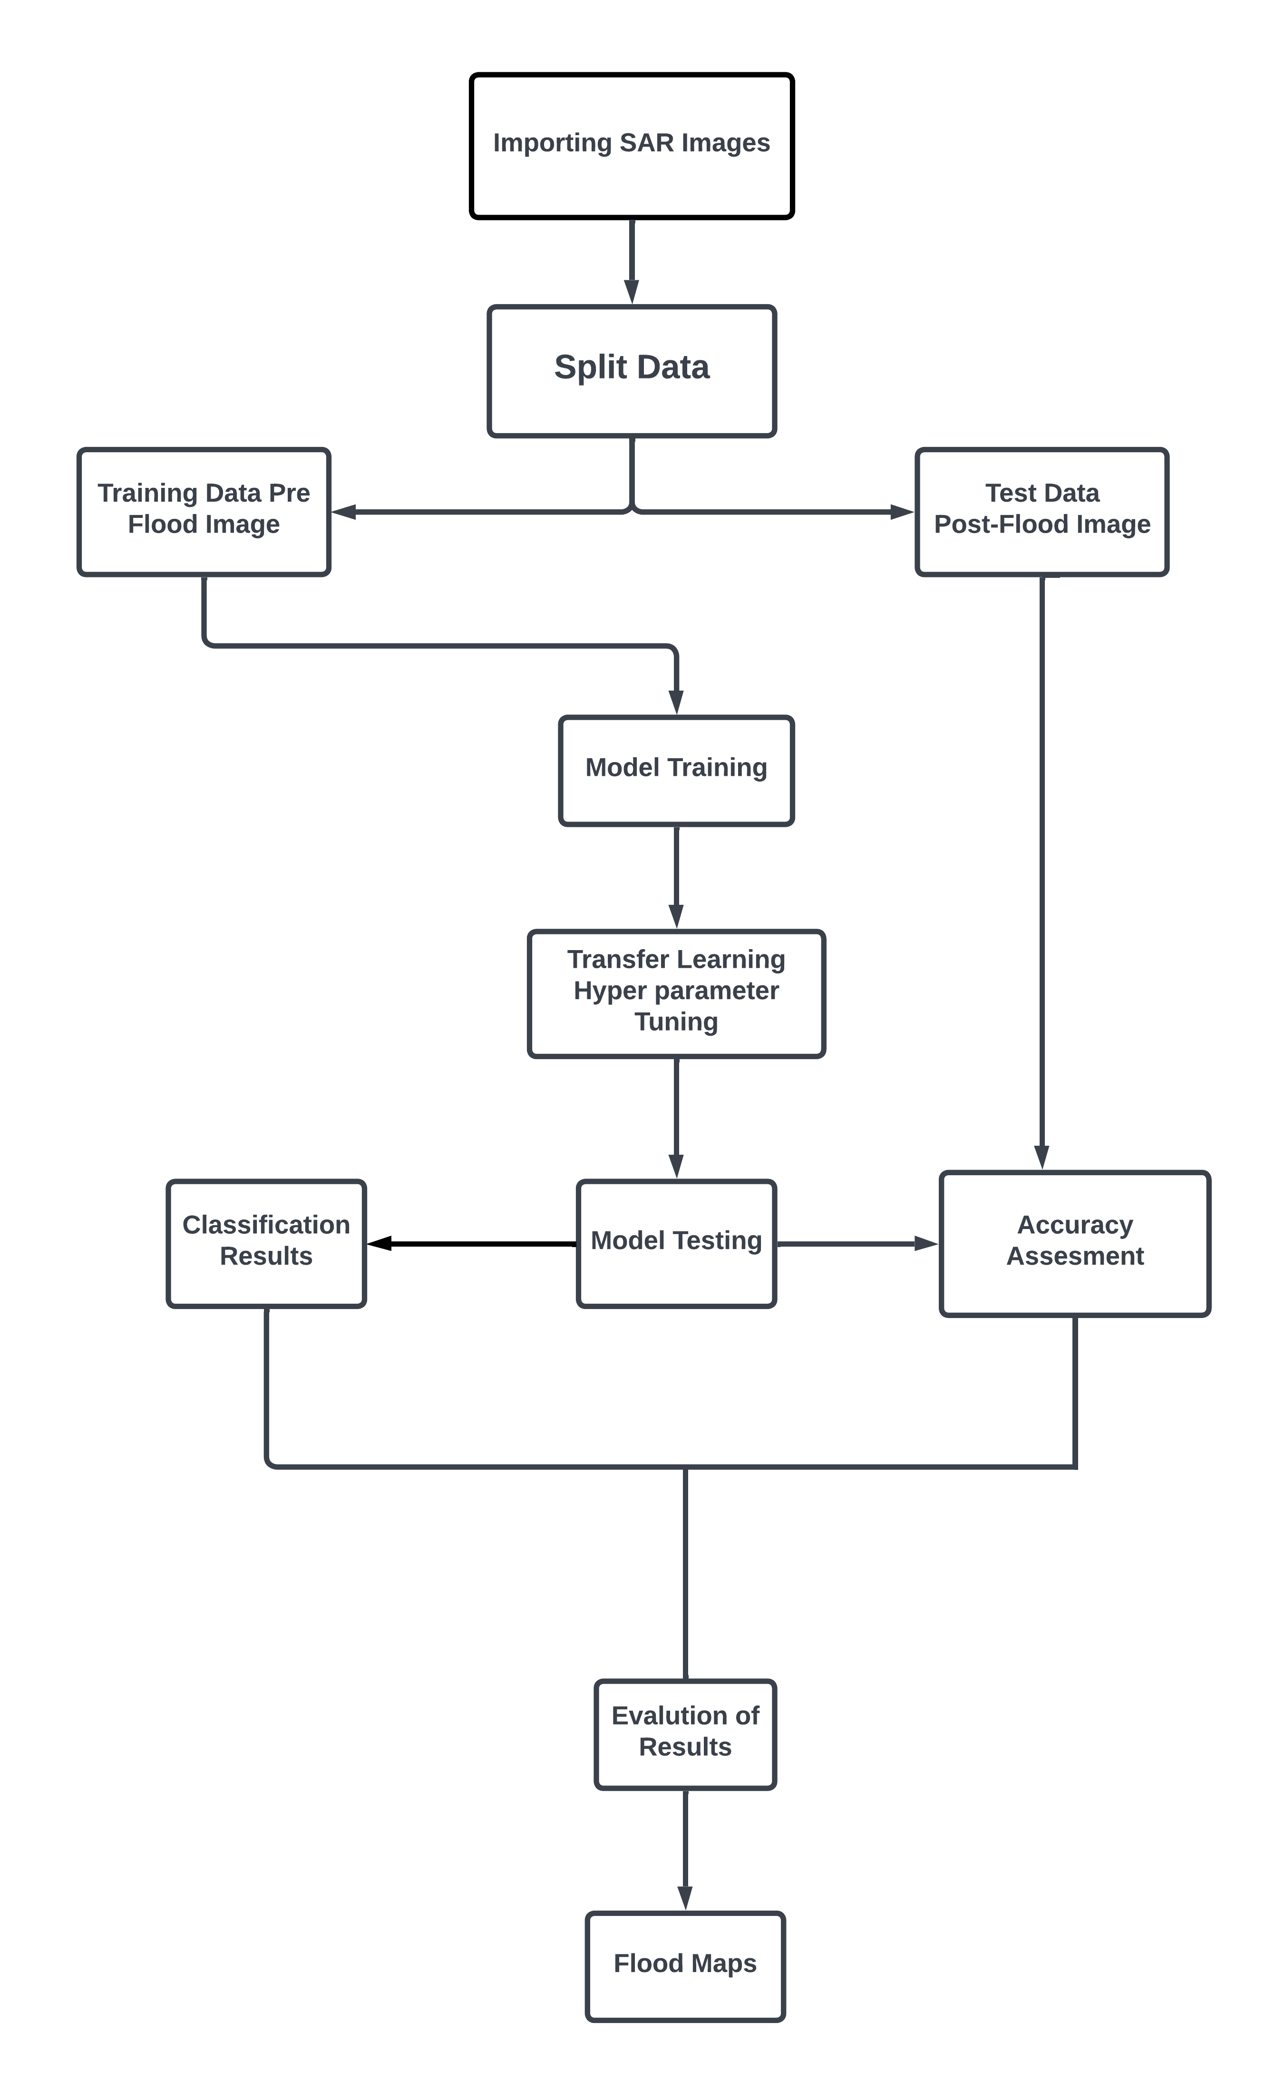

Fig 4: The above fig shows the work flow of the flood detection of SAR Images using Resnet GRU Model.

data point in your dataset is represented by y_i (True value for the i-th sample).Ϸ_i (I-th sample predicted value): This is
the value that the i-th data point in your model predicts; you compare it to the actual value to determine the loss. Similarly, we have calculated Euclidean loss, also known as L2 loss or Mean Squared Error (MSE) in machine learning and deep learning, is a common loss function used primarily for regression tasks. The general formula for the Eucliden loss is given by:

L = (1/N) * Σ(i=1 to N) (y_i - ŷ_i)²

Equation 2: General formula for Euclidian Loss

within my model, the batch size is set at 16 and the image dimensions are determined based on an input size of (64, 64). The Image Data Generator tool from TensorFlow is utilized for importing the dataset. Due to a unique preprocessing step, the pixel values are adjusted to fall within the range of -1 to 1. The generator works on grayscale images and takes input images in batches.

A test function is defined to visualize the denoising process, showing original, noisy, and denoised images side by side. The neural network model is created using a custom architecture with convolutional layers, batch normalization, and activation functions. This model is designed to take noisy images as input and output denoised versions.

Total Loss | Euclidian Loss | Total Variation Loss
933.2549 | 933.0271 | 1137.8212
847.2155 | 847.0009 | 1072.3312
750.9691 | 750.7586 | 1052.8681
Table 1: The table contain the values of Total Loss, Euclidian Loss, Total Variation Loss.

Result & Conclusion

Result
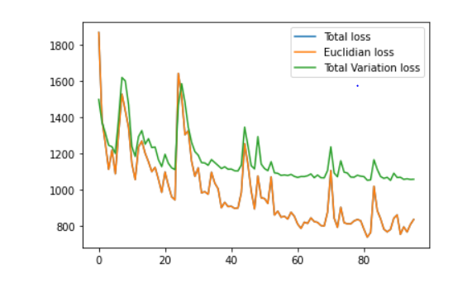
A detailed overview of the model's performance metrics across different training epochs is presented in (table 1). The table shows the three primary loss values: total loss, Euclidean loss, and total variation loss. As the training progresses, we observe a general trend of decreasing loss values, indicating the model's improving ability to denoise images. The total loss, which combines both Euclidean and total variation components, shows the overall model performance. The Euclidean loss, also known as Mean Squared Error (MSE), quantifies the pixel-wise difference between the denoised output and the ground truth. The total variation loss, on the other hand, measures the smoothness of the output image. These parameters offer fascinating details about the model's process of learning and its ability to reduce noise in images without reducing detail.
Fig 5: The above figure shows the graph of Total Loss, Euclidian Loss, Total Variation Loss
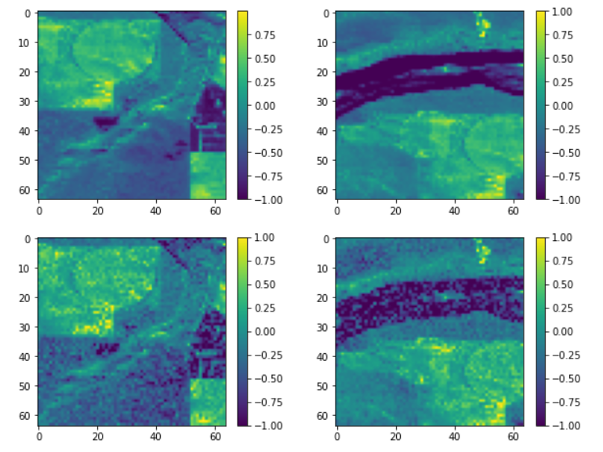
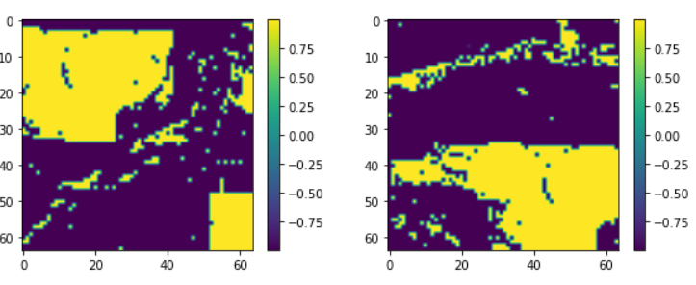
Fig 6: Shows the predicted areas which are affected by flood using Resnet GRU Model
Table 2: First row: A state-of-the-art network (Resnet-50) got accuracy on each image for the flood detection difficulty.
Model | Data | Accuracy
Resnet-50 | SAR Images | 0.753
Resnet-50+ GRU | SAR Images | 0.967
Second row: Recurrent neural networks provide accuracy determined by the order of image features.

Similarly, Table 2, where the measure has been calculated for each image in the dataset, shows the accuracy scores achieved with the Res-Nets for every image and the proposed network on every sequence. Some understanding of the importance of optical and SAR images for detecting floods is gained through tests done with the SEN12-FLOOD dataset. To start with, current technologies excel in optical and SAR imaging, capturing a vast amount of flood occurrences. However, it is clear that these events are most effectively characterized by the temporal dimension. It is true that taking the temporal dimension into account significantly reduces inaccuracy when using both optical and SAR pictures. Several points can be investigated in order to proceed. Firstly, multispectral data-handling architectures (Sumbul et al., 2019) ought to make it possible to extract additional information from every Sentinel 2 image and improve categorization. Second, compared to optical imagery, flood detection using SAR images could appear more difficult. Nonetheless, it seems that when since the sensor can see the water directly, the detection is identical to or superior than optical pictures; in contrast, when the water is obscured by vegetation, optical images are more helpful. According to the findings, SAR picture sequences were frequently used to incorrectly classify places in Zimbabwe where the flood primarily left behind moist ground and vegetation, but optical image sequences were not.

Conclusion
In order to detect flood occurrences in time series, we had used a dataset that is made up of optical and SAR pictures.
Additionally, we suggested a foundation for the spatial-temporal processing of residual and GRU networks in the multitemporal classification of floods. Our tests indicate that taking into account both of these modalities is worthwhile for this assignment. We had also calculated the loss function of the optical SAR Images to check how well our model is predicting the images and giving us the desired results. But in my model, we were unable to detect the images made up of multispectral. Future research may focus on more effective multispectral data processing techniques in addition to searching for improved fusion methodologies.

Acknowledgment
Radar data was supplied by the European Space Agency (ESA) for the Copernicus program. We appreciate Benjamin Bischke[13] for providing the Media-Eval Benchmarking Initiative for Media Evaluation and the initial Sentinel 2 dataset.

References

- Tanim, Ahad Hasan et al. “Flood Detection in Urban Areas Using Satellite Imagery and Machine Learning.” Water (2022): n. pag.J. Clerk Maxwell, A Treatise on Electricity and Magnetism, 3rd ed., vol. 2. Oxford: Clarendon, 1892, pp.68–73.
- Alganci, Ugur et al. “Determination of the Flooded Agricultural Lands with Spot 6 High Resolution Satellite Images: A Case Study of Menderes Plain, Turkey.” 2019 8th International Conference on Agro-Geoinformatics (Agro-Geoinformatics) (2019): 1-4.K. Elissa, “Title of paper if known,” unpublished.
- G, Selva Jeba and Chitra P. “Flood Detection from Satellite Images Using Self-Attention Empowered EfficientNetV2 Mechanism.” 2023 7th International Conference On Computing, Communication, Control And Automation (ICCUBEA) (2023): 1-4.
- Notti, Davide et al. “Potential and Limitations of Open Satellite Data for Flood Mapping.” Remote. Sens. 10 (2018): 1673.
- Anusha, N. and B. Bharathi. “Flood detection and flood mapping using multi-temporal synthetic aperture radar and optical data.” The Egyptian Journal of Remote Sensing and Space Science 23 (2020): 207-219.M. Young, The Technical Writer’s Handbook. Mill Valley, CA: University Science, 1989.
- Munawar, Hafiz Suliman et al. “Application of Deep Learning on UAV-Based Aerial Images for Flood Detection.” Smart Cities (2021): n. pag.
- Munawar, Hafiz Suliman et al. “UAVs in Disaster Management: Application of Integrated Aerial Imagery and Convolutional Neural Network for Flood Detection.” Sustainability (2021): n. pag.
- Zhang, Lianchong and Junshi Xia. “Flood Detection Using Multiple Chinese Satellite Datasets during 2020 China Summer Floods.” Remote. Sens. 14 (2021): 51.
- Mateo-García, Gonzalo et al. “Towards global flood mapping onboard low cost satellites with machine learning.” Scientific Reports 11 (2021): n. pag.
- Li, Sanmei et al. “Automatic near-real-time flood detection using Suomi-NPP/VIIRS data.” Remote Sensing of Environment 204 (2018): 672-689.
- Nemni, Edoardo et al. “Fully Convolutional Neural Network for Rapid Flood Segmentation in Synthetic Aperture Radar Imagery.” Remote. Sens. 12 (2020): 2532.
- Clément Rambour, Nicolas Audebert, Elise Koeniguer, Bertrand Le Saux, Michel Crucianu, Mihai Datcu, September 14, 2020, "SEN12-FLOOD : a SAR and Multispectral Dataset for Flood Detection ", IEEE Dataport, doi: https://dx.doi.org/10.21227/w6xz-s898.
- Bischke, B., Bhardwaj, P., Gautam, A., Helber, P., Borth, D., Dengel, A., 2017. Detection of flooding events in social multimedia and satellite imagery using deep neural networks. Working Notes Proceedings of the MediaEval 2017. MediaEval Benchmark, September 13-15, Dublin, Ireland, MediaEval.

